LAB EXPERIMENT RECORD

SET 14: Survey Results

Department | AIML
Course Code / Course Name | DSA0601 / Data Handling and Visualization
Experiment | Data Visualization using R
Name | KURUBA VANNUR SWAMY
Register Number | 192525265
Date | 8 october 2026
Day | thursday

Aim
To visualize the geographic distribution of cities using population and temperature information.

Dataset

Respondent | Question 1 | Question 2 | Question 3
1 | A | B | C
2 | B | A | D
3 | C | A | B

PROGRAM 1: Stacked Bar Chart
To visualize the distribution of answers for Question 1 using a stacked bar chart.
# # # Set 14 Q1 - Stacked Bar Chart question1 <- c("A", "B", "C")

answer_count <- table(question1)

barplot( answer_count,
main = "Question 1 Response Distribution", xlab = "Answers",
ylab = "Number of Responses",
col = c("lightblue", "lightgreen", "orange")
)

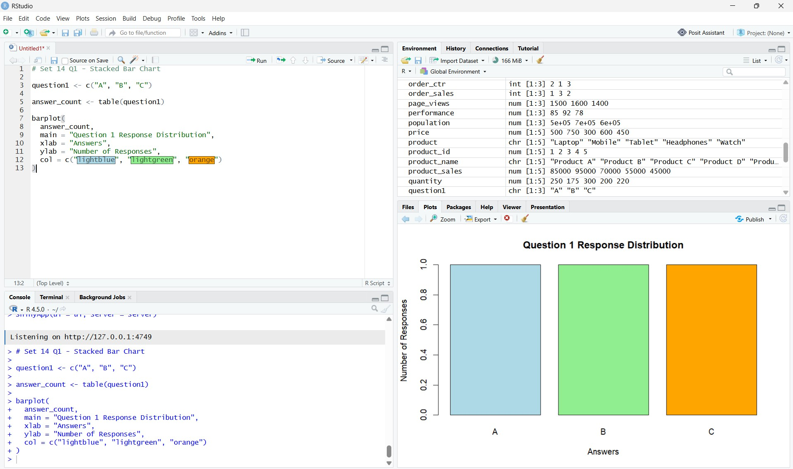

Observation:
- A = 1 response
- B = 1 response
- C = 1 response
Each answer has an equal frequency.

PROGRAM 2: Radar Chart
Base R does not have a built-in radar chart, so we can create a simple radar-style chart using Base R. First calculate the total number of A, B, C and D responses for all questions.
# Set 14 Q2 - Radar Chart question1 <- c("A", "B", "C")
question2 <- c("B", "A", "A")
question3 <- c("C", "D", "B")
answers <- c("A", "B", "C", "D")
q1 <- table(factor(question1, levels = answers)) q2 <- table(factor(question2, levels = answers))

q3 <- table(factor(question3, levels = answers))
overall <- q1 + q2 + q3
values <- as.numeric(overall)
angles <- seq(
0,
2 * pi,
length.out = length(values) + 1
)
values <- c(values, values[1])
- <- values * cos(angles)
- <- values * sin(angles)
plot(
x,
y,
type = "n",
asp = 1,
main = "Overall Survey Response Pattern",
xlab = "",
ylab = "",
axes = FALSE
)
polygon(
x,
y,
col = "lightblue",
border = "black"
)
points(
x,
y,
pch = 19
)text(
cos(angles[-length(angles)]) * 1.5,
sin(angles[-length(angles)]) * 1.5,
labels = answers

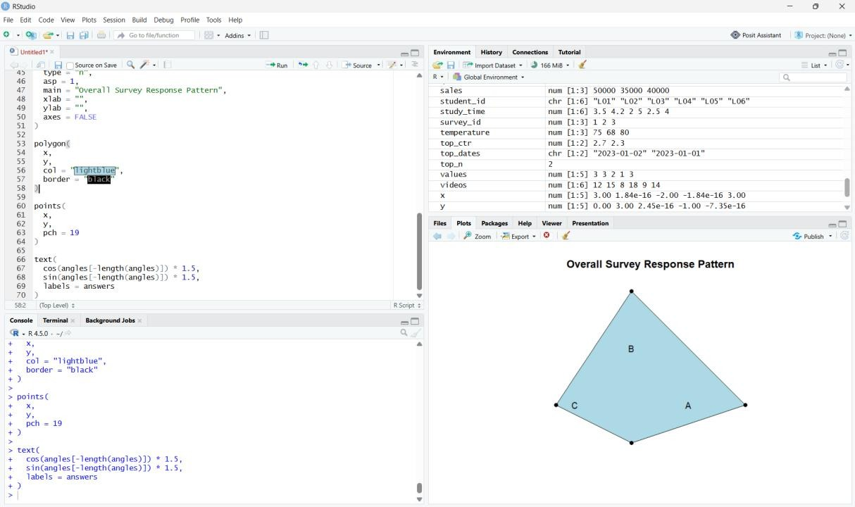

Observation:
The radar-style chart shows the overall response pattern across A, B, C and D..

PROGRAM 3: Survey Response Table
To display the survey response data for each respondent.
# # Set 14 Q3 - Survey Response Table respondent <- c(1, 2, 3)
question1 <- c("A", "B", "C")
question2 <- c("B", "A", "A")
question3 <- c("C", "D", "B") survey_table <- data.frame(
Respondent = respondent, Question_1 = question1, Question_2 = question2, Question_3 = question3
)
survey_table

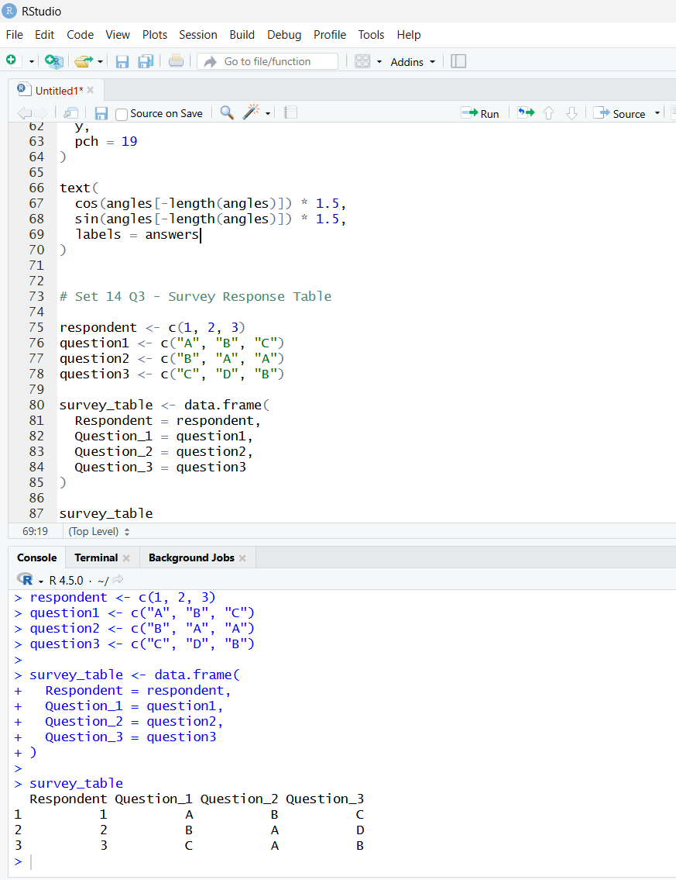

Observation
The survey responses of all respondents were successfully displayed in tabular form

PROGRAM 4: Survey Dashboard

library(shiny)

question1 <- c("A", "B", "C")
question2 <- c("B", "A", "A")
question3 <- c("C", "D", "B")

plot(
x,
y,
type = "n",
asp = 1,
main = "Overall Survey Response Pattern",
axes = FALSE
)

polygon(
x,
y,
col = "lightblue"
)

points(
x,
y,
pch = 19
)

text(
cos(angles[-length(angles)]) * 1.5,
sin(angles[-length(angles)]) * 1.5,
labels = answers
)
})

output$table <- renderTable({

data.frame( Respondent = 1:3,
Question_1 = question1, Question_2 = question2, Question_3 = question3
)
})
}

shinyApp(ui = ui, server = server)shinyApp(ui = ui, server = server))
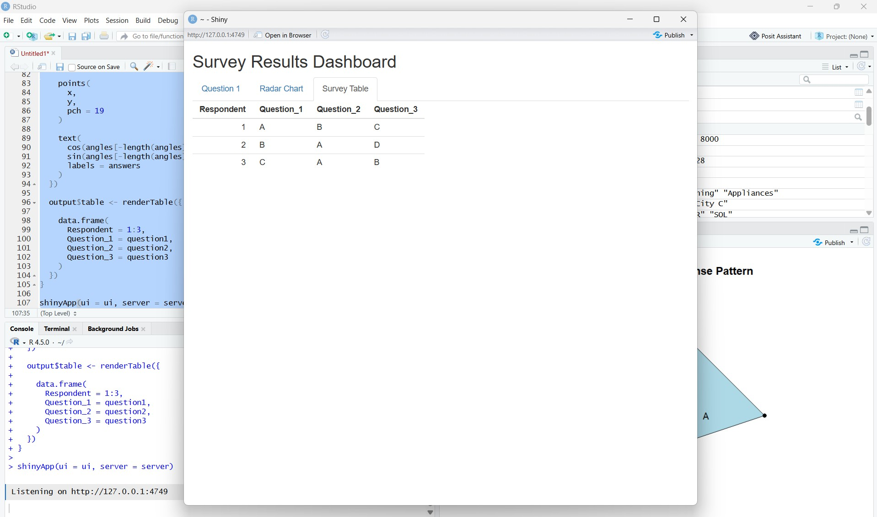
Output 4: Interactive Monthly Sales Dashboard

Observation: An interactive geographic dashboard was successfully developed in RStudio using Shiny.
.

Result:
The product category sales data was successfully analyzed using a funnel-style chart, pie chart, and table. An An interactive survey dashboard combining the stacked bar chart, radar-style chart and survey table was successfully developed using RStudio Shiny.

